36.18: a) Ignoring diffraction, the first five maxima will occur as given by:
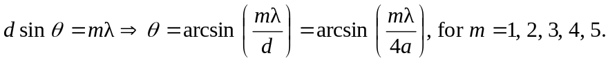
b)
So including diffraction, the intensity:

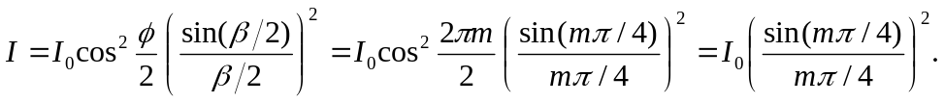
So for
